n r hands 

Contractor’s position CHECKLIST

|  |  |  |  |  |
| --- | --- | --- | --- | --- |
| Insurance qualification | |  | Background Qualification | |
|  | Liability Insurance |  |  | Local background History |
|  | Car Insurance |  |  | FDLE / FBI Background History |
|  |  |  |  |  |
| Application Qualification | |  | Certification for position | |
|  | Driver’s License / ID card |  |  | CPR & First Aide |
|  | Social Security Card |  |  | HIPAA |
|  | Vehicle Insurance & Registration |  |  | Infection Control |
|  | Resume |  |  | Diploma, GED, CNA, HHA & Medication Administration |
|  |  |  |  |  |
| Other Items | |  |  |  |
|  | Affidavit Of Good Moral Character |  |  |  |
|  | Fraud & Abuse Form |  |  |  |
|  | Sparklers |  |  |  |
|  | Noisemakers |  |  |  |
|  | Gifts |  |  |  |



|  |  |  |  |  |  |  |
| --- | --- | --- | --- | --- | --- | --- |
|  | 2021 | | | | |  |
|  | NEW YEAR’S EVE CHECKLIST | | | | |  |
|  | INVITATIONS | |  | DECORATION | |  |
|  |  | Make guest list |  |  | Confetti / streamers | |
|  |  | Send invitations |  |  | Lights | |
|  |  | | | | | |
|  | Entertainment | |  | FOOD & DRINKS | | |
|  |  | Music playlist |  |  | Lots of ice | |
|  |  | Photo booth |  |  | Assorted beverages | |
|  |  |  |  |  | Appetizers / snacks | |
|  |  |  |  |  | Champagne | |
|  |  | | | | | |
|  | Other Items | | | | |  |
|  |  | Buy balloons |  |  | Sparklers | |
|  |  | Utensils / plates / cups |  |  | Noisemakers | |
|  |  | Games |  |  | Gifts | |
|  |  |  |  |  |  | |
|  |  |  |  |  |  | |
|  |  |  |  |  |  | |
|  |  |  |  |  |  | |

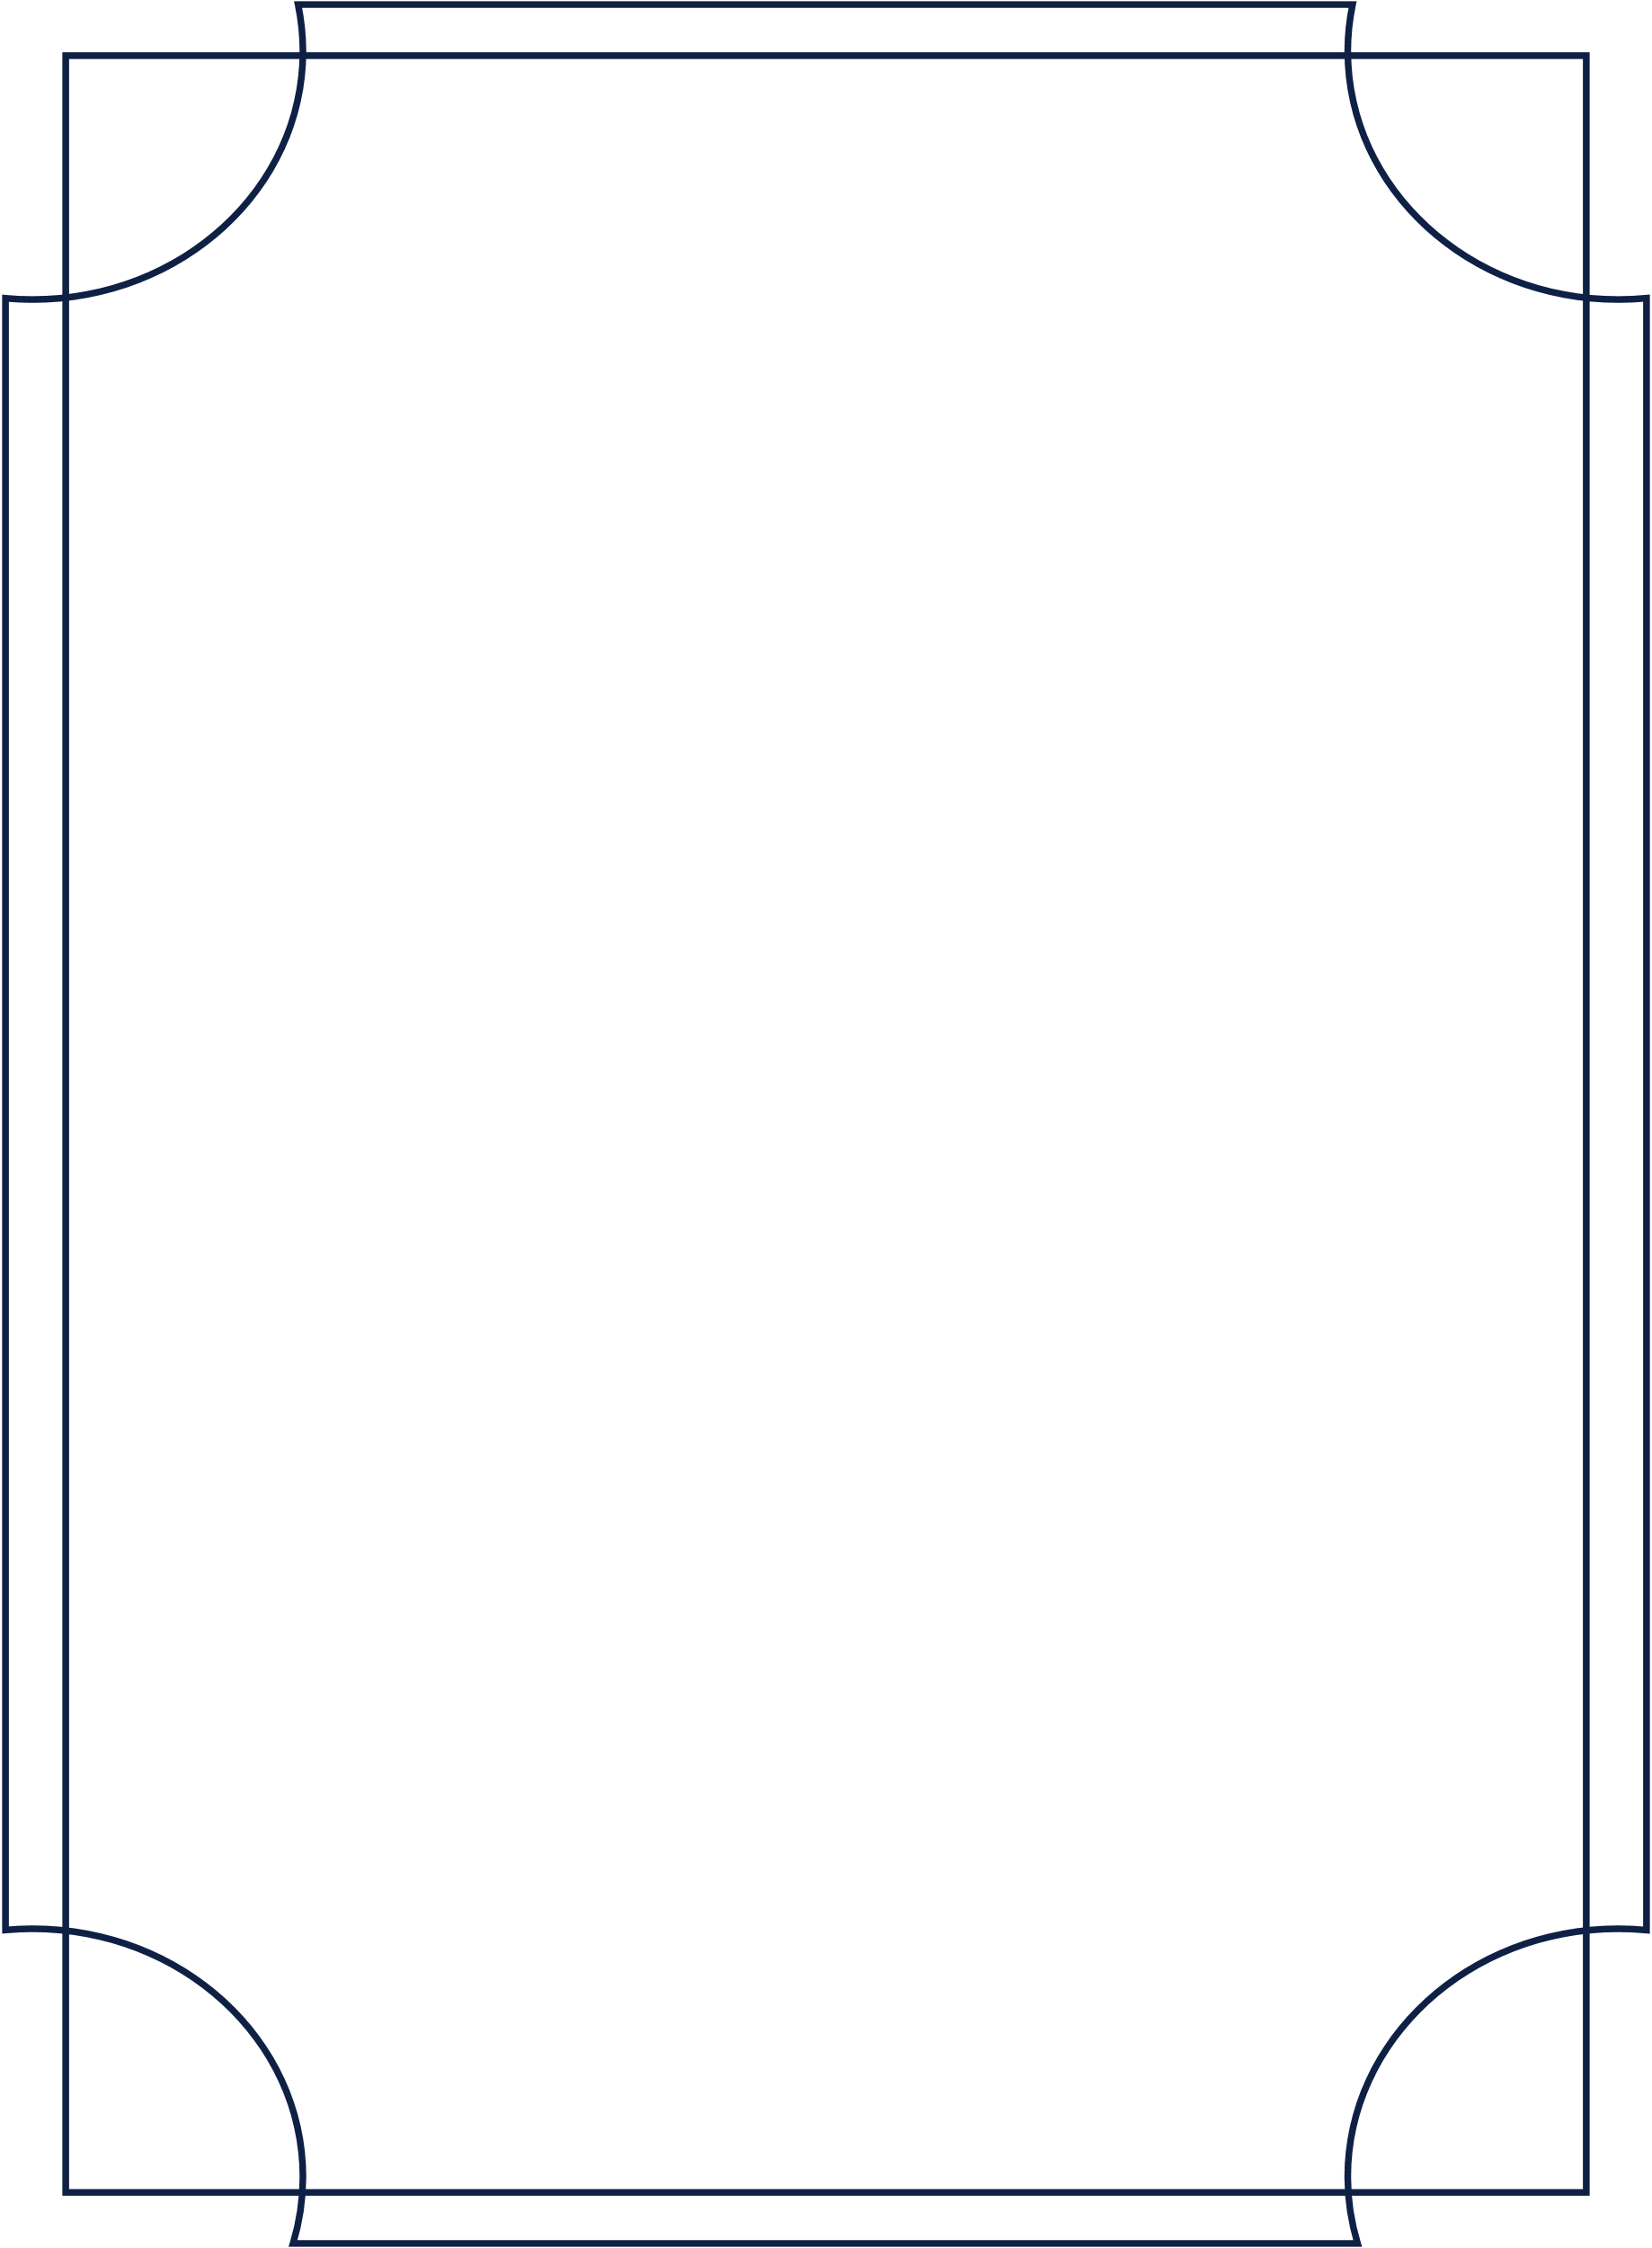

2021

NEW YEAR’S EVE CHECKLIST

|  |  |  |  |  |  |
| --- | --- | --- | --- | --- | --- |
| INVITATIONS | |  | DECORATION | | |
|  | Make guest list |  | |  | Confetti / streamers |
|  | Send invitations |  | |  | Lights |
|  |  |  | |  |  |
| Entertainment | |  | | FOOD & DRINKS | |
|  | Music playlist |  | |  | Lots of ice |
|  | Photo booth |  | |  | Assorted beverages |
|  |  |  | |  | Appetizers / snacks |
|  |  |  | |  | Champagne |
|  |  |  | |  |  |
| Other Items | |  | |  |  |
|  | Buy balloons |  | |  | Sparklers |
|  | Utensils / plates / cups |  | |  | Noisemakers |
|  | Games |  | |  | Gifts |
|  |  |  | |  |  |